EXPERIMENT 11: - Demonstrate virtualization by Installing Type-2 Hypervisor in your device, create and configure VM image with a Host Operating system (Either Windows/Linux).

Step 1: - Install VM Ware PlayStation

Step 2: - Create new virtual machine

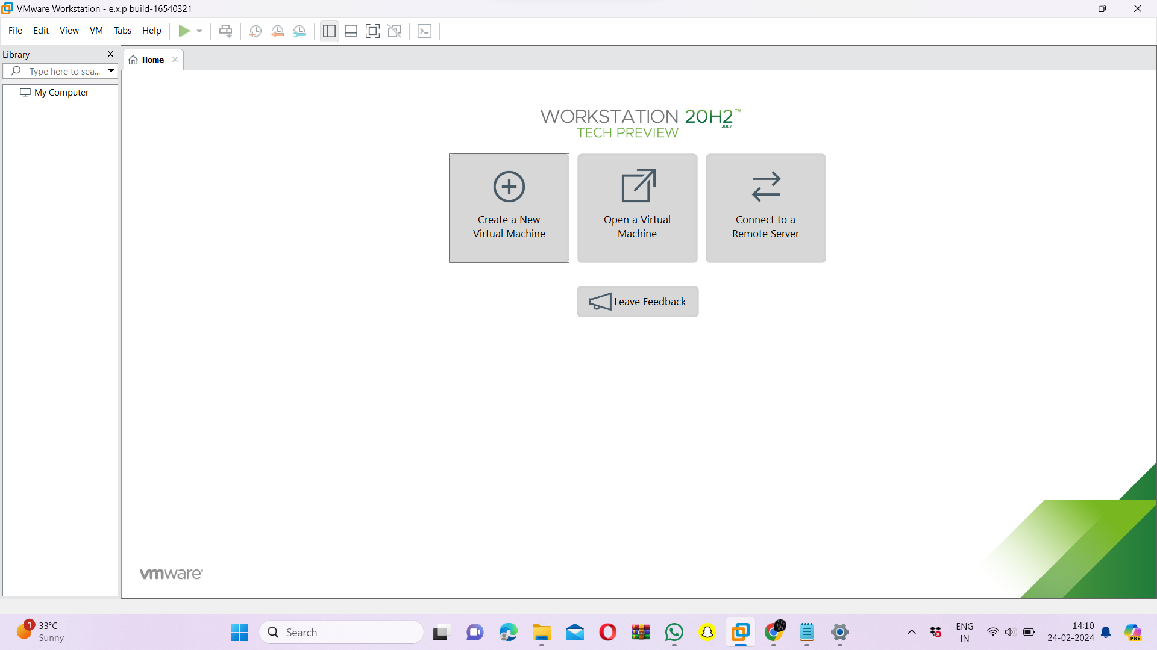

Step 3: - Choose Typical option and click Next

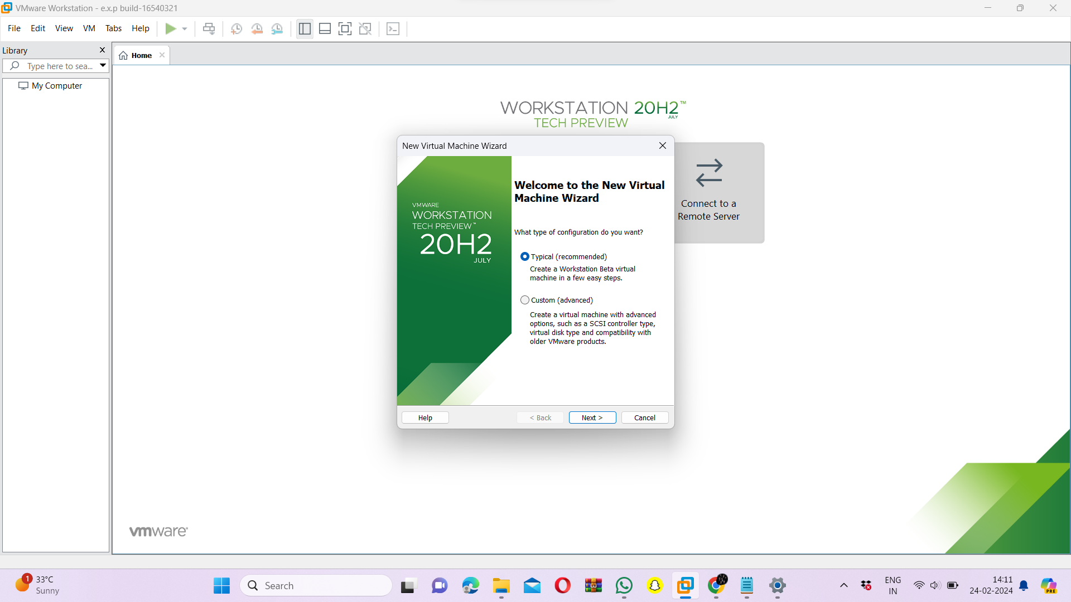

Step 5: - Click on Installer disc image file and browse your iso file and click next

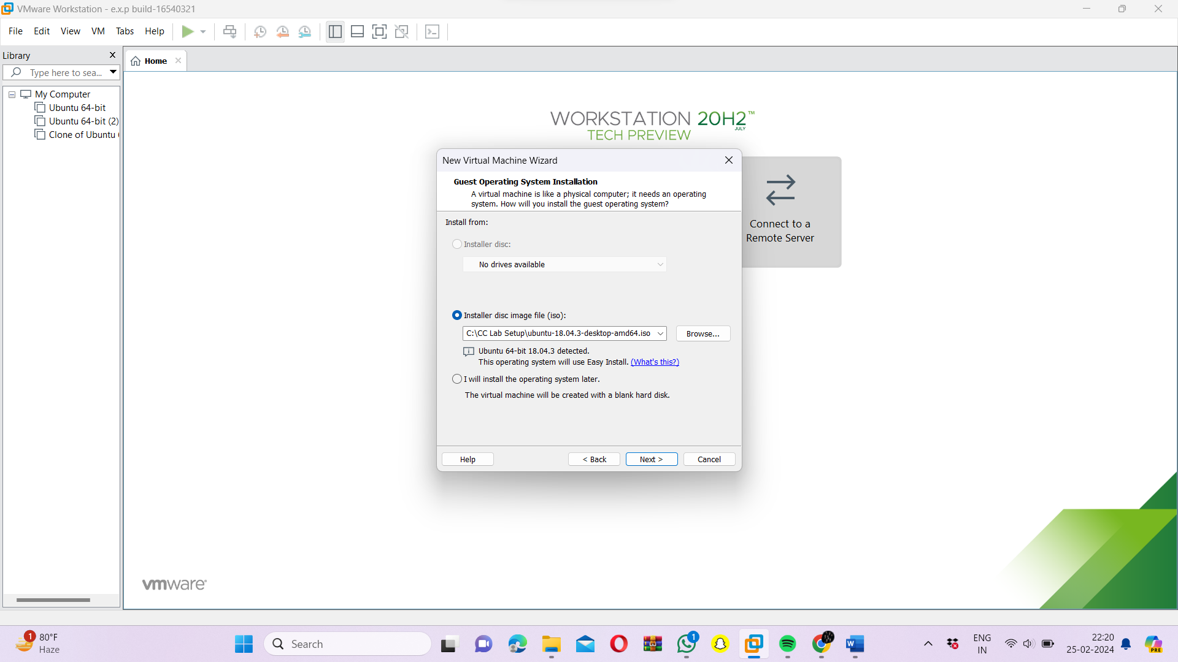

Step 6: - Enter your credentials and click next

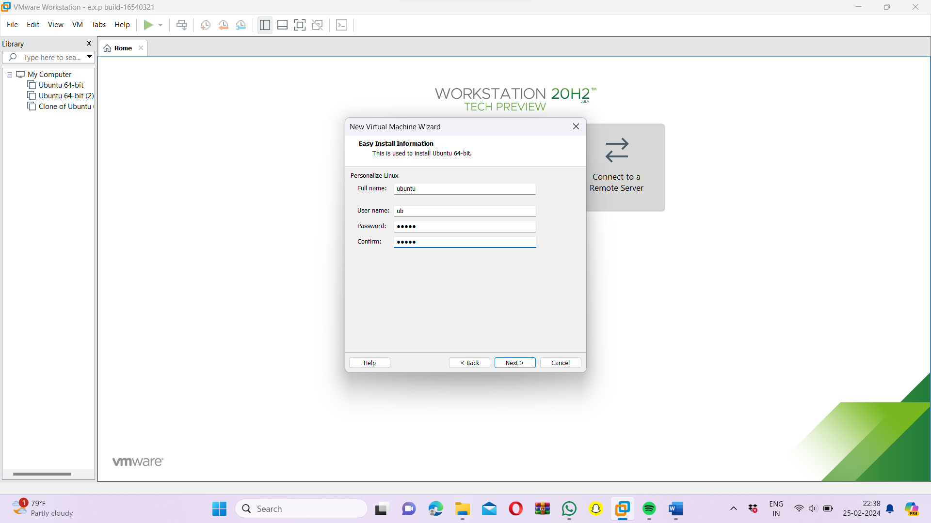

Step 7: - Enter the name of virtual machine and click next

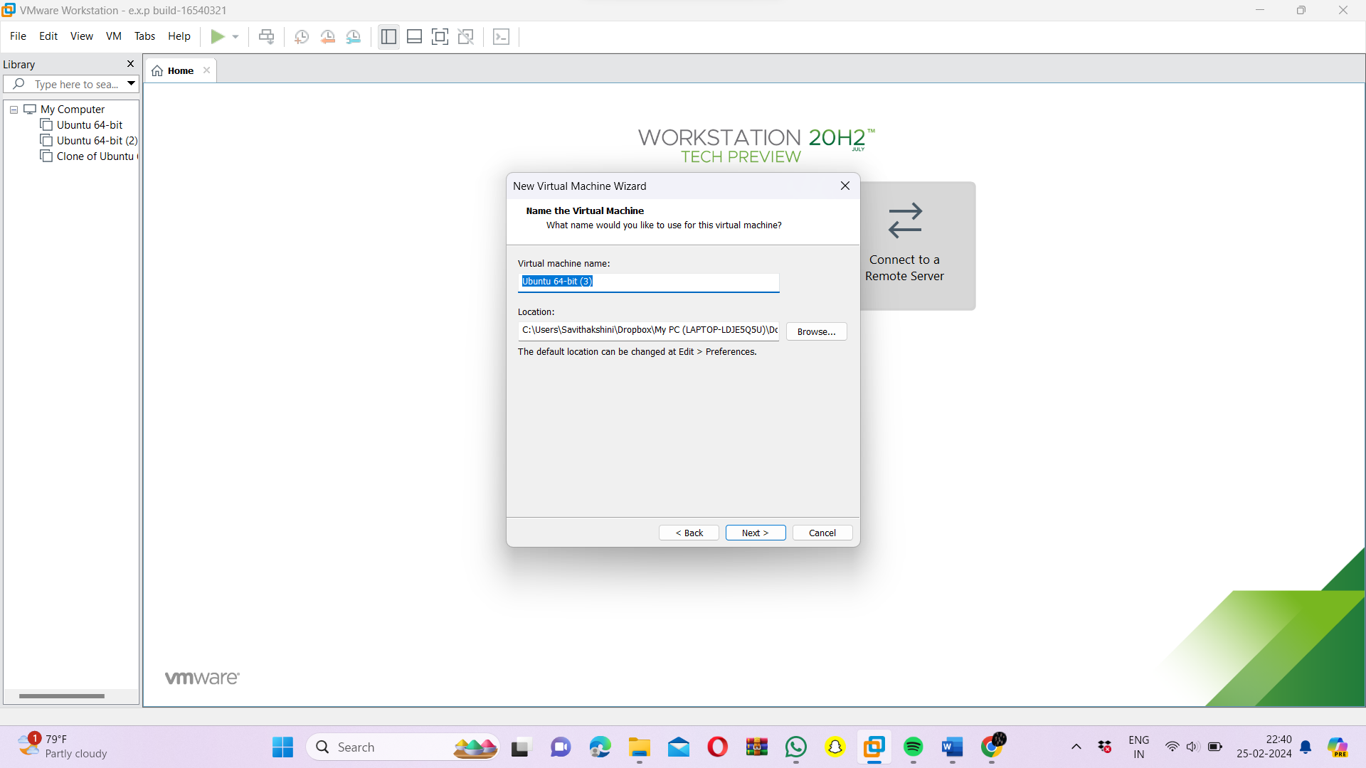

Step 8: - Enter the disk space and click next

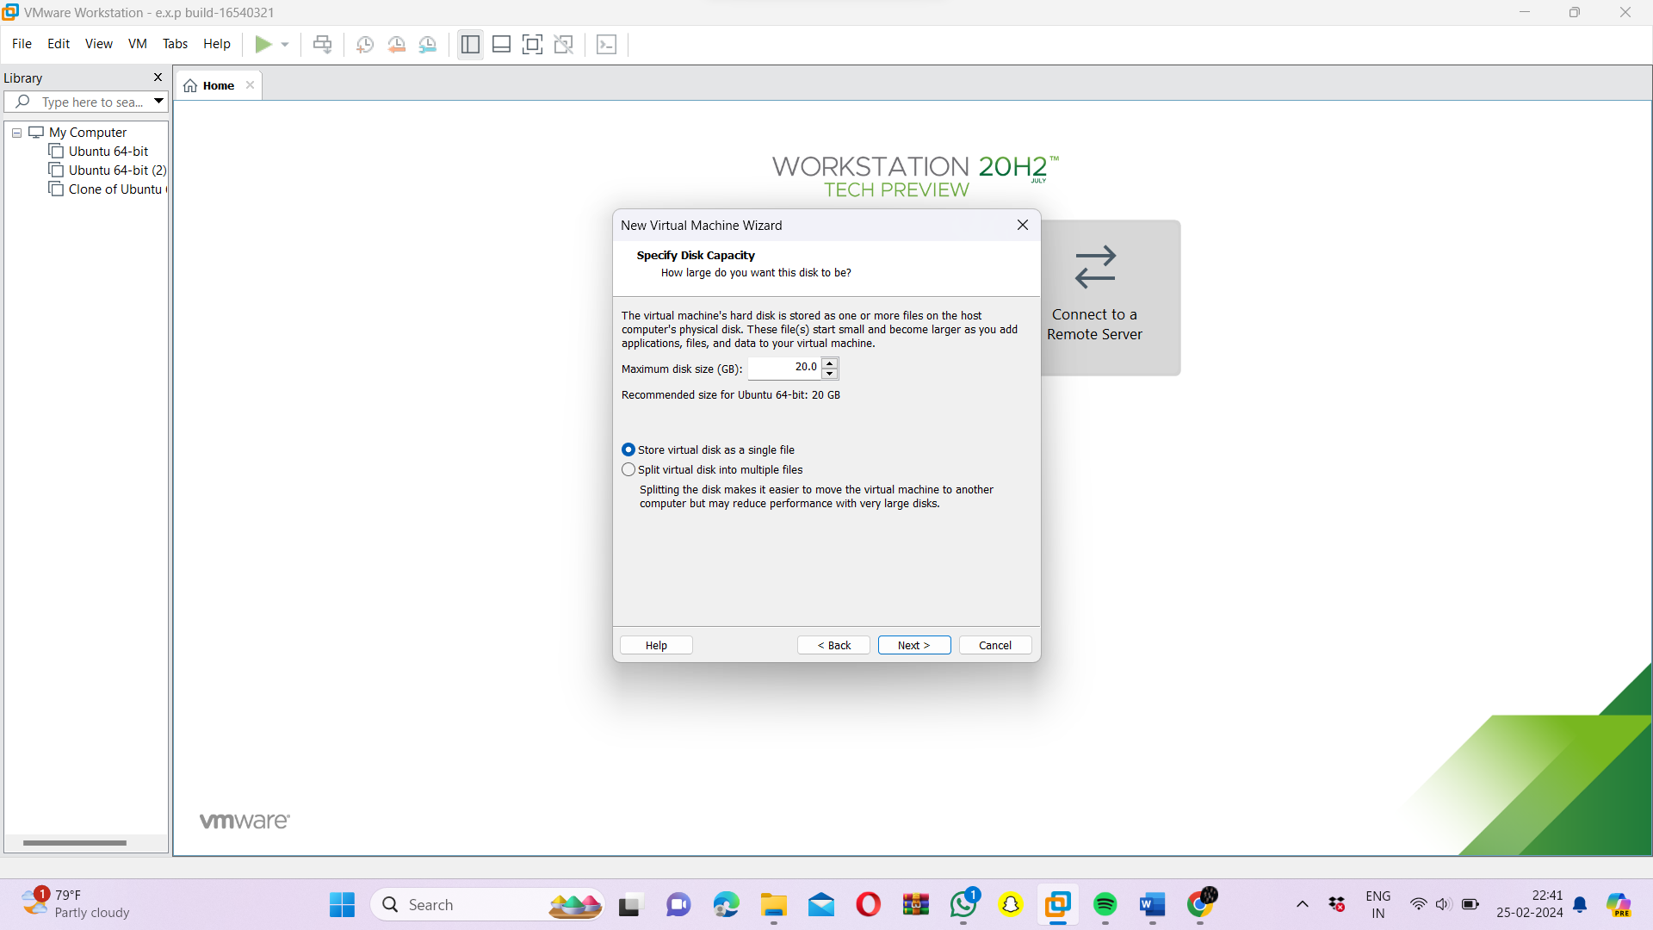

Step 9: - Check the summary and click on next

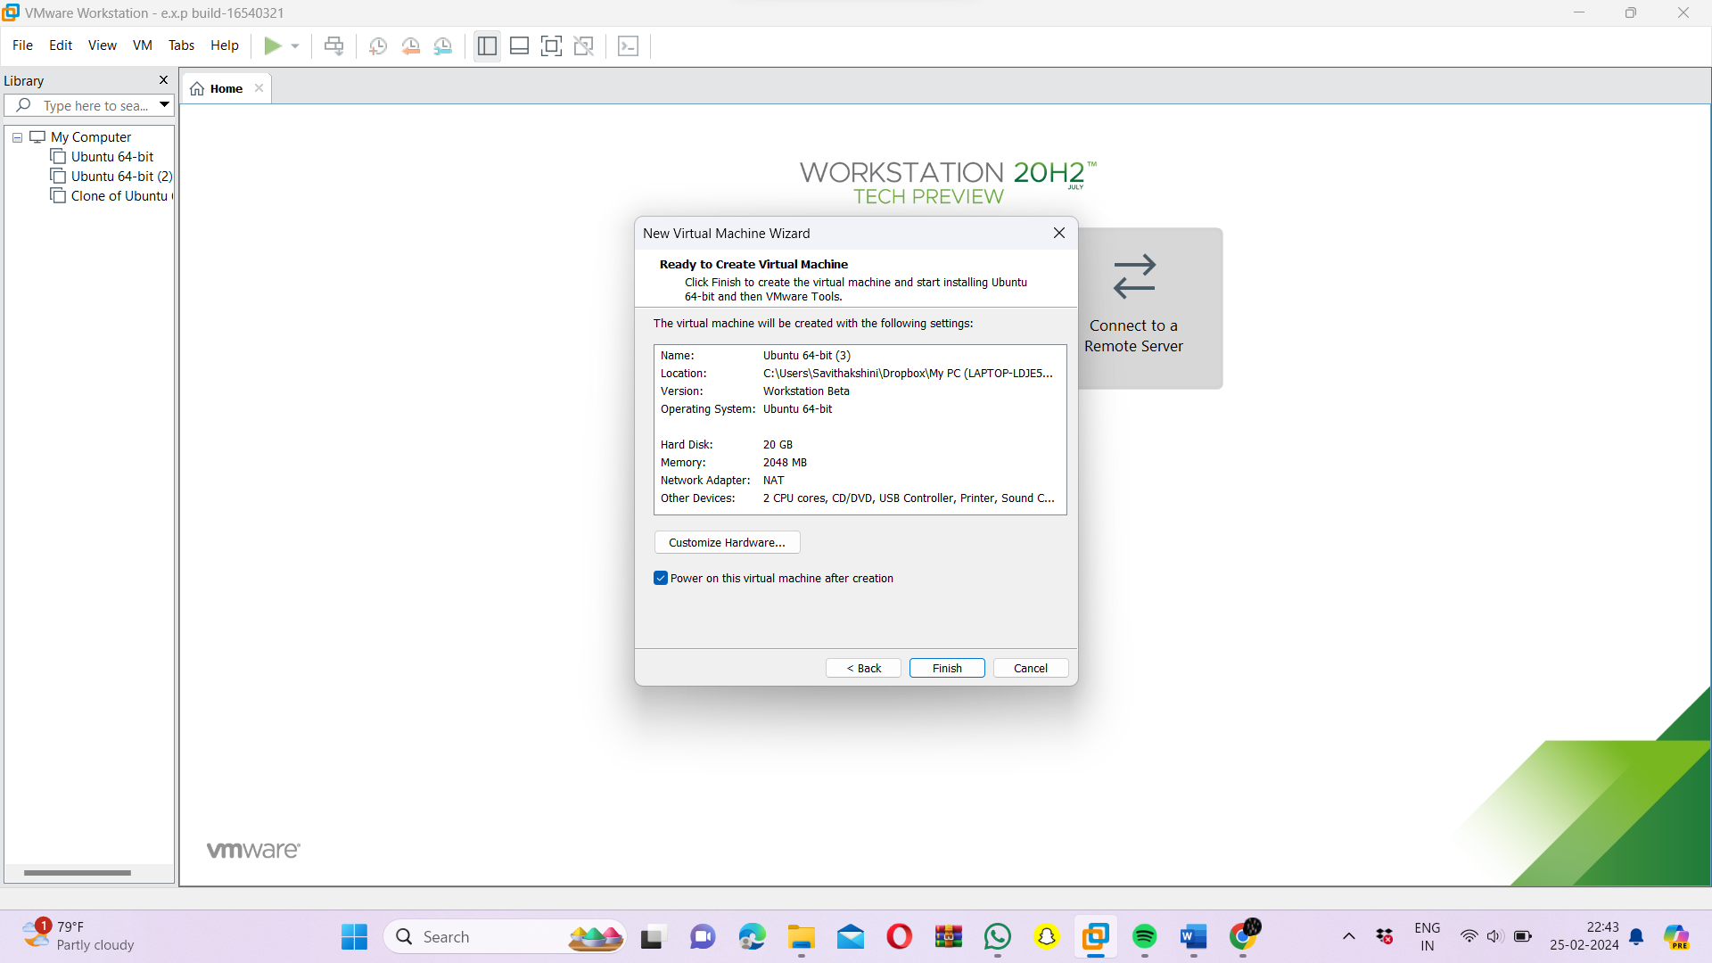

Step 10: - The VMware will start running

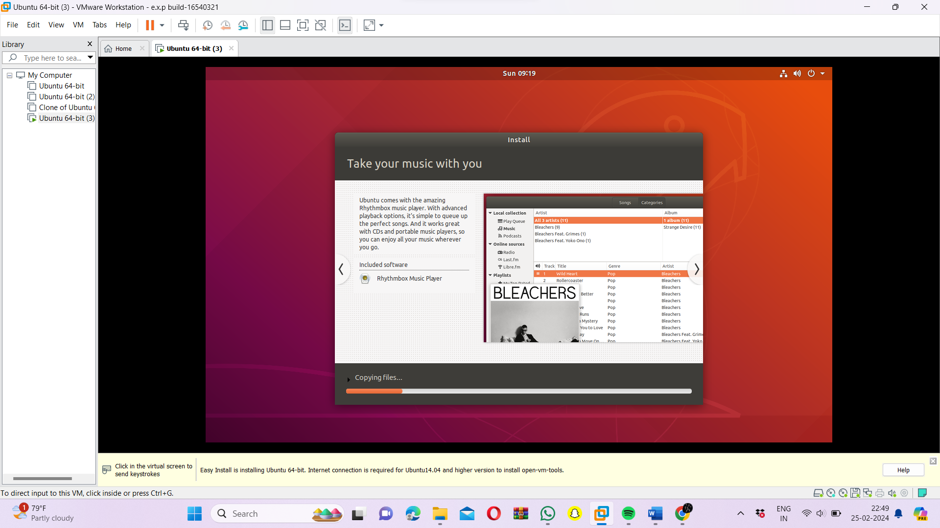

Step 11: - The installation process will start

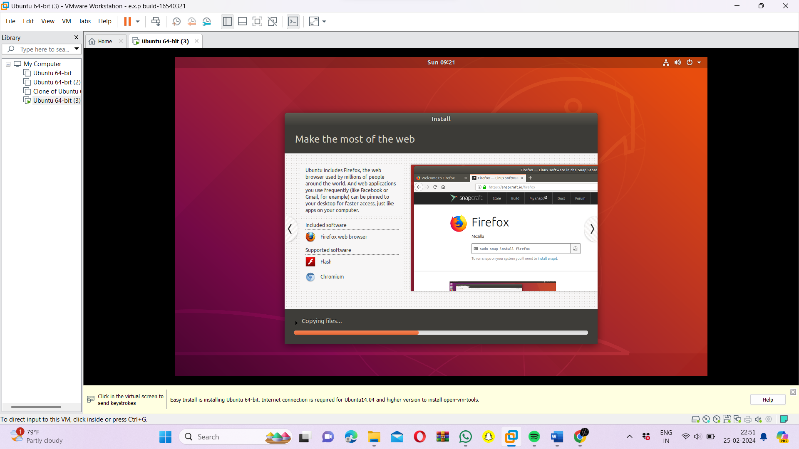

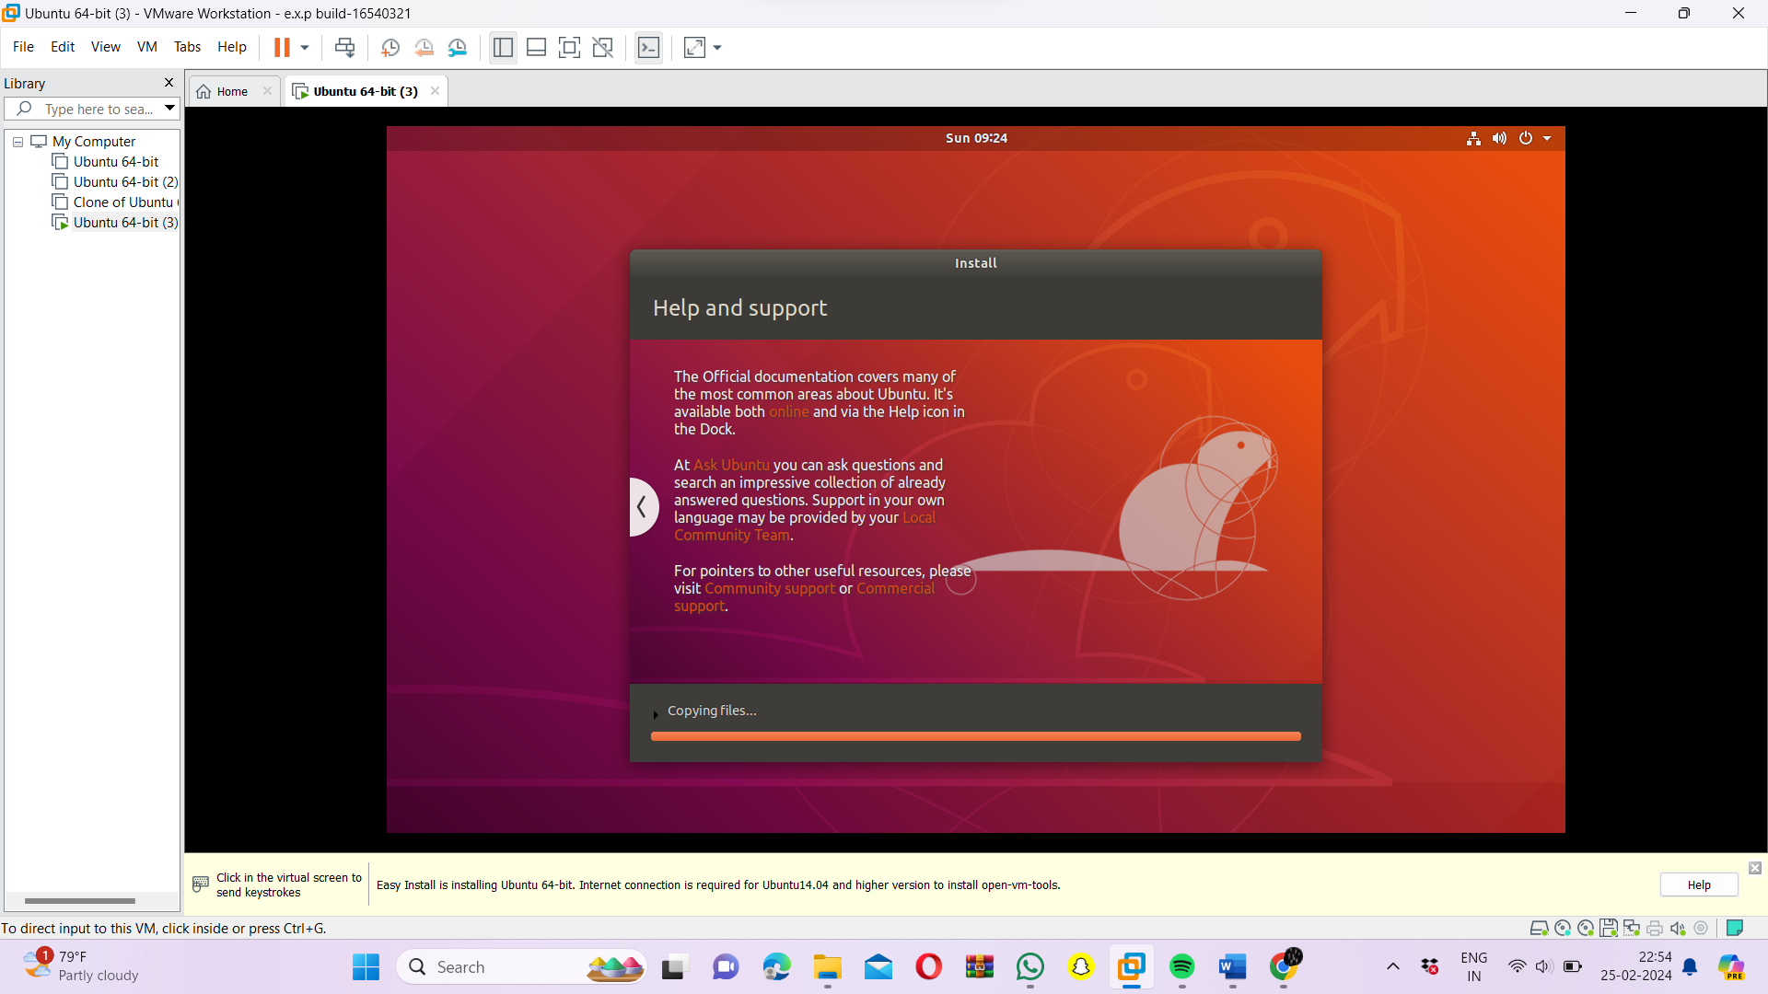

Step 12: - After the installation, enter your credentials and sign in

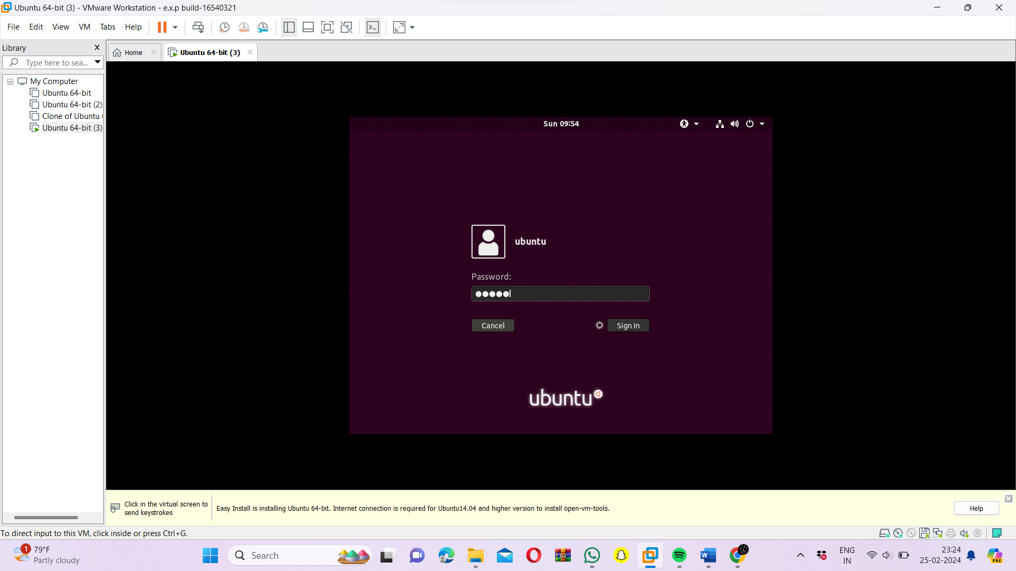

Step 13: - The required virtual machine was created.

